

Peer Tutoring Platform
User Manual

Due before 5pm 24/04/2026
South East Technological University Carlow

Written By
Student Name: Temur Rustamov
Student Number: C00280204
Student Email: C00280204@setu.ie

Supervised By
Lecturer Name: Jamal Tauseef
Email: Jamal.Tauseef@setu.ie

Table of Contents
1. Prerequisites 3
2. Cloning the Repository 3
3. Project Structure 4
4. Backend Setup 5
5. Environment Variables for Backend 5
6. Frontend Setup 7
7. Running the Application 8
8. Ports Reference 8
9. Glossary 9

Table of Figures
Figure 1:Commands to use for checking the versions compatible for running the Tutoring Platform locally 3
Figure 2: Choosing “Download ZIP” option to run the project locally 4
Figure 3: The project structure of the Peer Tutoring Platform 4
Figure 4: Commands to install all dependencies to run the backend side of the project 5
Figure 5: Creating a configuration file for the backend 5
Figure 6: Template for environment variables inside the backend directory 6
Figure 7: Installing dependencies for frontend and navigating into the right folder to run the Peer Tutoring Platform locally 7
Figure 8: Environment variables used for frontend 7
Figure 9: Command to start and install locally a MongoDB database 8
Figure 10: Command to navigate into the backend directory and run it in the second terminal 8
Figure 11:Command to navigate into the frontend directory and run it in the last terminal 8

Abstract
The purpose of this manual is to provide a clear guide for running the application of the hosted AWS EC2 instance. It covers all the steps required to configure and start the project including installing necessary prerequisites, setting up the backend and the frontend environments, configuring environment variables.
It is worth noting that a hosted version of the project is available and running on an AWS EC2 instance. Please, follow this link to get access to the Peer Tutoring Platform: http://tutorm3.club/
However, in the event that the instance is no longer accessible due to the cost factor, this manual provides all the steps necessary to run the application locally.

Prerequisites
The prerequisites to run this project locally are as follows:
- Node.js* v20.19.5
- MongoDB* cluster
- Git*
- npm* 10.8.2

Please note credentials for Google OAuth 2.0* and AWS S3* are mandatory for using authentication through Google and uploading files to AWS S3 buckets. These tokens are private and not included in the repository. Without them, email and password login and text posting still work.
The commands to check your versions are as follows:

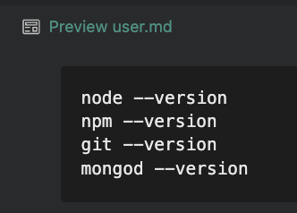
Figure 1:Commands to use for checking the versions compatible for running the Tutoring Platform locally

Cloning the Repository
The project has a public visibility set on. Please download it as a zip file and move it into your project folder.
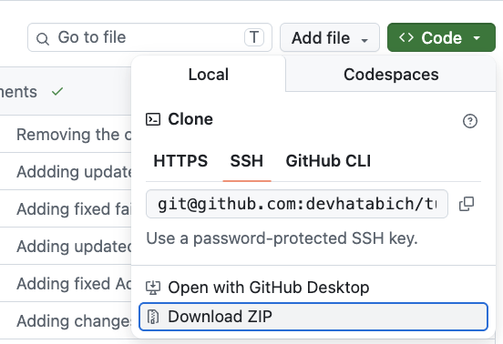
Figure 2: Choosing “Download ZIP” option to run the project locally

Project Structure
This repository has several top level directories. However, please take it into your consideration there for running the project locally there are only two of them that are required:
- back*
- front*
The project structure should look like:
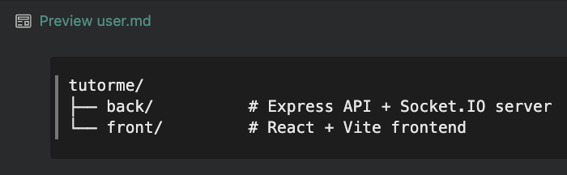
Figure 3: The project structure of the Peer Tutoring Platform

Backend Setup
Once the zip file is installed and an user is in the right directory, navigating into the folder for backend and installing all Node.js dependencies will be the next step. Express.js*, MongoDB library, Socket.io*, bcryptjs*, JSON Web Token, AWS SDK* and all other dependencies including Jest for integration testing should be installed together as well.
The following commands to accomplish these goals are as follows:
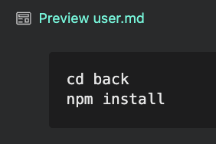
Figure 4: Commands to install all dependencies to run the backend side of the project

Environment Variables for Backend
The backend reads all secrets from a configuration file that is specifically designed for the environment inside the backend.
The command to create it inside the backend directory is as follows:
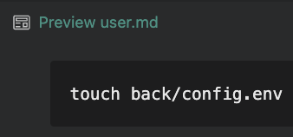
Figure 5: Creating a configuration file for the backend
Inside that file, an user is supposed to set values manually for environment variables. A template should look as follows:
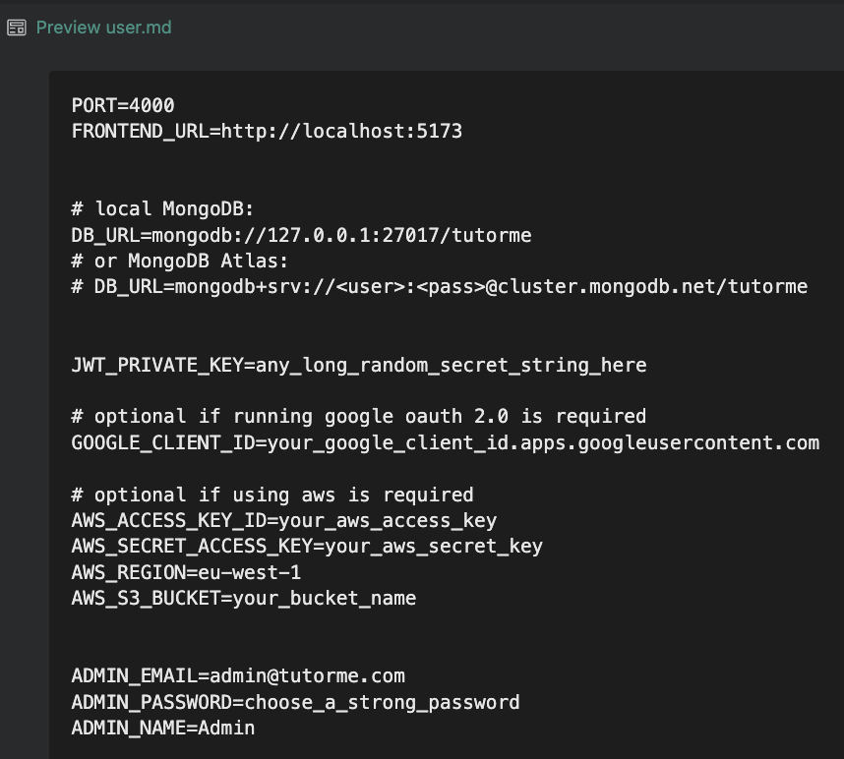
Figure 6: Template for environment variables inside the backend directory

As it is shown below in Table 1, there is a brief description of what each variable does and whether it is required to run the project locally.

Table 1: Brief description of environment variables used inside the backend folder.
Variable: | Purpose:
PORT (required) | Port the Express Server listens on. Use 4000
FRONTEND_URL (required) | Allows CORS* from the React server. Use http://localhost:5173
DB_URL (required) | MongoDB connection string. Local or Atlas both work.
JWT_PRIVATE_KEY (required) | Secret used to sign authentication tokens. Set to any long random string.
GOOGLE_CLIENT_ID (optional) | Enables Google sing-in. Without it, only email and password login works.
AWS_ACCESS_KEY_ID (optional) | AWS variable that is needed for image uploads to S3 Bucket. Without them the presign endpoint will fail, but text only posting still works.
AWS_SECRET_ACCESS_KEY (optional) | AWS variable that is needed for image uploads to S3 Bucket. Without them the presign endpoint will fail, but text only posting still works.
AWS_REGION (optional) | AWS variable that is needed for image uploads to S3 Bucket. Without them the presign endpoint will fail, but text only posting still works.
AWS_S3_BUCKET (optional) | AWS variable that is needed for image uploads to S3 Bucket. Without them the presign endpoint will fail, but text only posting still works.
ADMIN_EMAIL (optional) | This variable is used to create an admin account on first setup. Without those, no admin user is seeded, but if it is required, it can be created in MongoDB manually.
ADMIN_PASSWORD (optional) | This variable is used to create an admin account on first setup. Without those, no admin user is seeded, but if it is required, it can be created in MongoDB manually.
ADMIN_NAME (optional) | This variable is used to create an admin account on first setup. Without those, no admin user is seeded, but if it is required, it can be created in MongoDB manually.

Frontend Setup
For running frontend locally, a second terminal is required to be used at the same time with running backend. Once the second terminal window is opened, an user should navigate into the frontend folder and install dependencies.
The commands to navigate into the frontend folder and installing dependencies are as follows:
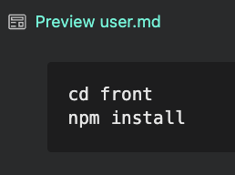
Figure 7: Installing dependencies for frontend and navigating into the right folder to run the Peer Tutoring Platform locally
The frontend uses prefixed environment variables for Vite*. An user should create a configuration environment file inside the directory for frontend.
The environment variables should look as it is shown in Figure 8:
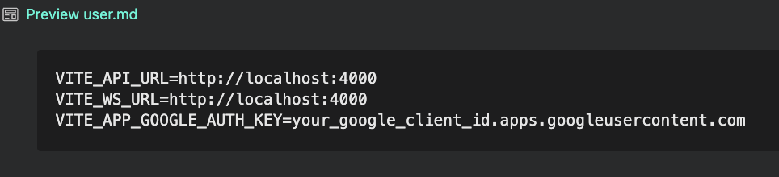
Figure 8: Environment variables used for frontend

Running the Application
It is important to mention, that to achieve running the Peer Tutoring Platform locally all 3 terminal windows are required to be used. The first terminal will be allocated for starting and running MongoDB database. The second terminal will be used for running the backend part of the project. Finally, the last terminal will be responsible for running the frontend side of the Peer Tutoring Platform.
The commands to run all three parts of the project are as follows:
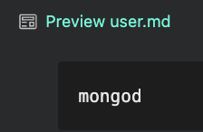
Figure 9: Command to start and install locally a MongoDB database
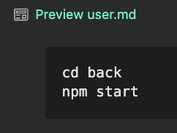
Figure 10: Command to navigate into the backend directory and run it in the second terminal
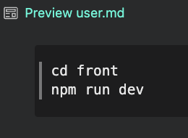
Figure 11:Command to navigate into the frontend directory and run it in the last terminal

Ports Reference
As it is shown below in Table 2, these are the ports used locally. It is important to mention, that none of them should be already in use before starting.

Table 2: Port Reference
Port Number: | Description:
:5173 | React Frontend. A server that will open the application in the browser.
:4000 | Express Backend. This port is used for REST API* calls and Socket.io server.
:27017 | MongoDB. This is a default MongoDB port that is needed for installing the project locally.

Glossary
Term Name | Term Description
AWS S3 | Amazon Simple Storage Service. A cloud storage service used to store and retrieve uploaded files such as profile images.
AWS SDK | Amazon Web Services Software Development Kit. A set of libraries used to interact with AWS services programmatically from the backend.
bcryptjs | A JavaScript library used to hash and verify user passwords before storing them in the database.
CORS | Cross-Origin Resource Sharing. A browser security mechanism that controls which domains are allowed to make requests to the backend server.
Express.js | A Node.js web framework used to define backend routes, middleware and API logic.
Git | A version control system used to track changes in source code.
Google OAuth 2.0 | An open authorisation protocol that allows users to sign in using their Google account without creating a separate password.
MongoDB | A document oriented NoSQL database used to store system data.
Node.js | A JavaScript runtime environment used to execute backend application code.
npm | Node Package Manager. A tool used to isntall and manage JavaScript dependencies.
React.js | A JavaScript library used to build the frontend user interface.
REST API | Representational State Transfer Application Programming Interface. A set of HTTP endpoints used to communicate between the frontend and the backend.
Socket.io | A library used to support live communication between connected users.
Vite | A frontend build tool used to serve the React application during local development.

